Installation Procedure for:
Master Processor in
PT 5210 VariTime� Digital Sync Generator

The master processor in the PT 5210 VariTime™ Digital Sync Generator can be installed by technical qualified users.
Exchange of the master processor is typically only required for configuration of some special versions or for update of the master software version.
The version of the master software can be identified during power op of the PT 5210 VariTime Digital Sync generator. Immediately after the self-test the display shows “Version: xx.x-yy.y”, where xx.x indicates the master processor software version and the yy.y indicates the internal sync pulse generator software version.

- Open the PT 5210 by removing the top cover.
- Identify the master processor on the processor module mounted flat behind the display module.
- By use of suitable IC extractor remove the master processor.
- Insert the new processor. Take care to orientate the processor correctly.
- Mount the top cover on the PT 5210.
- Perform a factory reset: While pressing the three buttons ARROW RIGHT and ARROW LEFT simultaneously turn on the power.
- Observe that the menu includes the changes to the SDI test signal generator menu.
- Place the option type plate on the side of the generator in order to make later identification possible
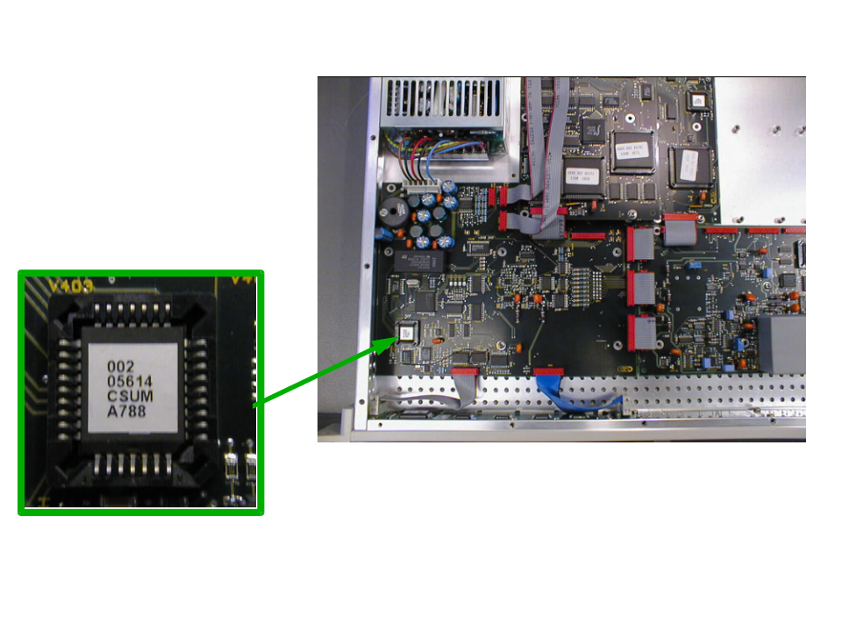
Picture 1: The positioning of the master processor. The lower right corner on the processor is indicated by a cut in the chip.

